**Syed Yusha Abbas Kazmi**

**BSIT**

**3A**

**AI Lab Task No. 5**

Input:

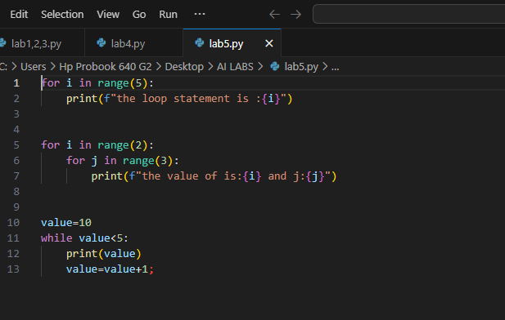

Output:

